كمي إعلان ديونيه

أبريل - نيسان سفنتين
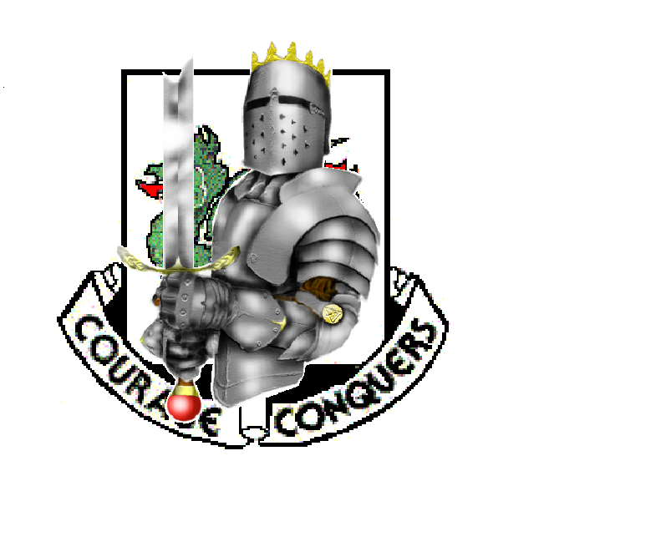

Ad-Diwaniyah, Iraq
17 April 2004

On 4 April 2004, after twelve months in Iraq, the 1st Armored Division was preparing to re-deploy to its home station of Germany; meanwhile, the cleric Muqtada al-Sadr had plans of his own. He was a man who many Iraqi’s believed was using his grandfather’s revered name to usurp a place of power in the new Iraq. After failing to incite an Islamic rebellion back in October, 2003, Sadr was preparing his militia for another attempt at an Iraqi insurgency. His following had grown, and now Sadr waited for the right moment to unleash his Mehdi Militia. Nobody knew that Sadr had chosen today.
As the Executive Officer (XO) of Alpha Company, 2-37 Armor, I was busy preparing to ship the bulk of the company’s supplies and equipment south to Kuwait, with the majority of our combat vehicles to make the journey a few days later. Task Force 2-37 Armor (Iron Dukes) had been assigned the northeastern portion of Baghdad, including the overpopulated slum area formerly known as Saddam City, now Sadr City. With a transition of authority to the 1st Cavalry Division only days away, TF 2-37 was focusing on the tasks necessary for redeployment. That all changed at 1600 on 4 April 2004 when Sadr’s militia attacked an Iraqi Police station, isolating Alpha Company, 2-5 Infantry (Lancer) of 1st Brigade, 1st Cavalry Division. C Company, 2-37 Armor (Crusader) was still TACON (under tactical control) to Lancer Battalion and it was immediately dispatched as a Quick Reaction Force to Sadr City. Crusader Company, followed closely by the remaining combat power of TF 2-37, attacked into Sadr City to rescue 2-5 IN, which had already suffered seven KIAs at the police station. After successfully repelling the Mehdi Militia that night, TF 2-37 prepared for the inevitable: the 1st Armored Division was being extended in Iraq for an additional four months.
With the extension official, TF 2-37 continued attacking militia forces in Sadr City for the next eleven days before officially relinquishing control to 1st Cavalry Division. TF 2-37 was then given orders to travel southwest to Al Kut and aid Ukrainian forces in restoring control to that city. Within days, Al Kut was secured and power restored to the CPA (Coalition Provisional Authority) and Ukrainian forces. So once again, TF 2-37 would be on the move, this time with orders to An Najaf, home of Muqtada Al-Sadr. The Task Force was given a simple task: destroy the Mehdi Militia and capture or kill Muqtada Al-Sadr. The Task Force prepared to move its base of operations from Al Kut to An Najaf, sending out all wheeled vehicles and the bulk of the Battalion leadership in a series of convoys on the evening of April 16th. With absolutely no enemy contact on their route, no one could have predicted what lay ahead for the final convoy.

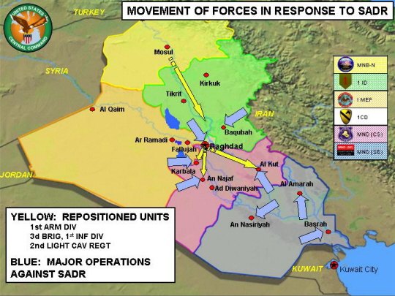
On April 17th, elements from A/2-37AR, B/2-37AR, C/2-37AR, HHC/2-37AR, 1175th TRANS, 2123rd TRANS, 596th TRANS, and A/1/2CAV were task organized to conduct a HET (Heavy Equipment Transport) convoy from Al Kut to Camp Duke, in the vicinity of An Najaf, a distance of well over 250 kilometers. With the Battalion headquarters already in An Najaf, the convoy was placed under the command of Captain Erik Peterson, the Assistant S-4. All sixty five of the Battalion’s tracked vehicles were loaded onto HETs, large tractor-trailers capable of hauling the sixty-nine ton tanks, for the trip to An Najaf. This was meant to conserve fuel, reduce the wear and tear on the vehicles and allow the crews to focus on security during the convoy. Most vehicles held the crews inside with any excess soldiers accompanying the two HET drivers inside their cab. This way the crews were able to man the crew served weapons systems on the vehicles, augmenting the security that the Apache White scouts were providing throughout the entire convoy.

Captain Peterson broke the convoy into two serials of roughly thirty-three vehicles a piece, to depart Camp Delta approximately 45 minutes apart. However, after a morning of delays and confusion as to the route to be taken, both serials departed Camp Delta at the roughly 1300 on April 17th.

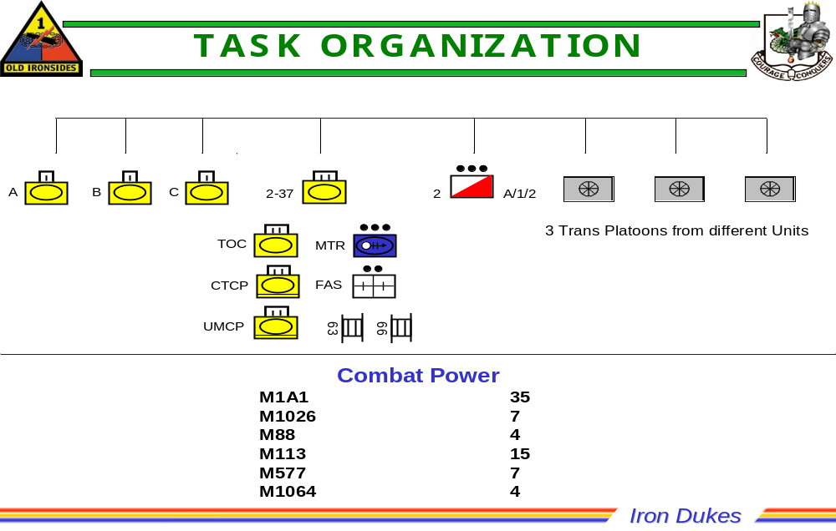

The convoy had very few problems for the first few hours, traveling through some small towns and stopping periodically to fix flat tires on the HETs. At about 1800, the HET convoy entered the city of Ad Diwaniyah enroute to Camp Duke via ASR (Alternate Supply Route) Orlando. The HET company commander, Warrior 5, was informed by the escort element, Apache White 1, that an overturned semi-trailer was blocking the primary route through the city, and that the escort element had identified an alternate route that would force the convoy through the city. After receiving approval from Captain Peterson and Warrior 5, the convoy began its move along the bypass.
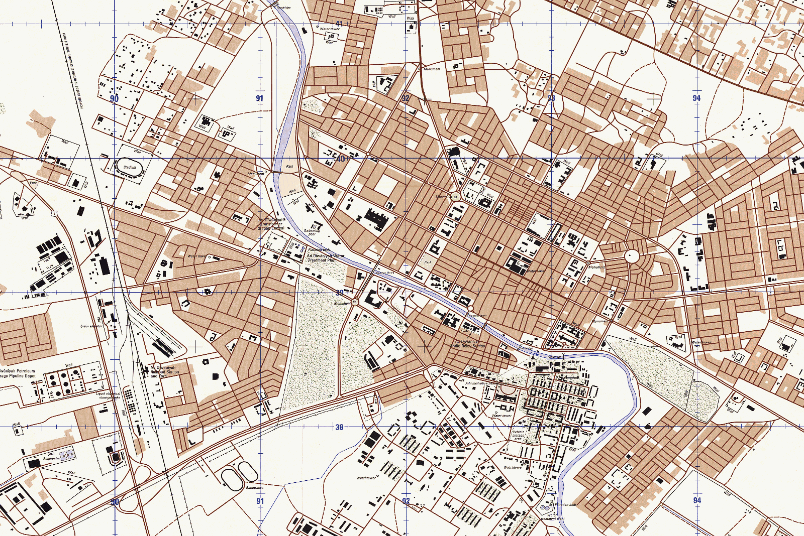
Ad-Diwaniyah Routes
Site of Overturned Truck – Forced ALT RTE
Primary Route
Alternate Route
At about 1830, the convoy made its first hostile contact at MA 92103965, receiving sporadic small arms fire from both sides of the street. The HETs in contact reacted to this contact by stopping their vehicles and returning small arms fire. Hearing reports on the battalion net, I contacted all Aggressor tank elements not currently engaged with the enemy and warned them of the imminent threat along our bypass route. At this point, the HET loaded with A66, which was the first tank in the road march, took the first casualty. SGT Jonathan Hartman, who was in the tank commander’s cupola, was shot in the right abdomen and dropped into the turret. PFC Eric Mullins, A66’s loader and the only other soldier on the tank, immediately started to assess SGT Hartman’s wounds and provided aid, while at the same time still defending himself from the attackers. “It took me awhile to determine what had happened to John. I just thought he was reloading when I noticed his face had gone white.” (Mullins, 2004) For SGT Hartman to be given proper medical treatment, the convoy had to get out of direct fire contact, and PFC Mullins did all he could to get his HET and the convoy moving. While defending his tank and caring for SGT Hartman, PFC Mullins threw anything within arms reach until he was able to gain the attention of the HET crew. I made a quick assessment on my map and ordered all vehicles to consolidate across the southern bridge at MA 89513720. It took some time for this information to be disseminated from my battalion net call to the individual companies and finally to the transportation units. Eventually, after this initial contact, the HETs moved forward, looking for the designated escape route. Realizing that the convoy was again moving, the enemy poured heavy small arms and RPG fire from both sides of the street and rooftops at MA 91993955. Monitoring the Warrior frequency, I could tell that the HET drivers did not know how to properly react to contact and merely stopped in place for an estimated fifteen to twenty minutes, until they received guidance from higher authority. The M1026 escort HMMWV’s were constantly trying to suppress the enemy and facilitate movement, but the HETs continued to remain in place. We were now caught in the enemy’s kill zone, and unless we moved rapidly, all hell was about to break loose.
At this point, the HET loaded with my tank was located at the intersection of MA 91993955. We were receiving heavy RPG and small arms fire. “I looked back and saw twenty to thirty tracer rounds bounce all around the XO as he was out of the hatch firing his M4.” (Welch, 2004) There were numerous enemy combatants on the rooftops of both residential and commercial buildings firing at the convoy, creating an in-depth ambush. While engaging enemy in a nearby window, I noticed a volley of RPG’s fired towards our location. The first RPG impacted into the street, and we were showered with gravel and asphalt. A few seconds later, the second and third RPGs impacted with an enormous explosion into the right rear of my tank’s hull. Shaken from the impact, I did a quick assessment of my crew and the tank. With everything still in working order, I identified the attacker’s position about 300 meters down the main street to the east. I then immediately killed him with .50 caliber fire while my gunner, SGT Shaun Ellertson, continued to fire the loader’s M240 machine gun on insurgents on the rooftops from the western side of the street. The enemy would present themselves from alleyways and from the rooftops momentarily while they fired and then would seek cover. It made our target acquisition more difficult, but it also decreased their accuracy. Once we had identified the main alleys, we were able to neutralize these threats and focus overwhelming firepower onto the attackers. My tank prioritized small arms fire into the near attackers, and our crew served weapons into the distant attackers, RPG teams, and buildings these attackers were using for cover.
After switching to my AK-47 due to malfunctions with my M4 carbine, I caught a white flash from the corner of my eye. An enemy 7.62 round had gone through my backpack directly in front of me. It was only then that I realized these guys were trying to kill me, an epiphany that seemed surreal up to that point. While still in contact, I did my best to facilitate the movement of the convoy to the reconsolidation point. After what seemed like an eternity, my HET began to move.
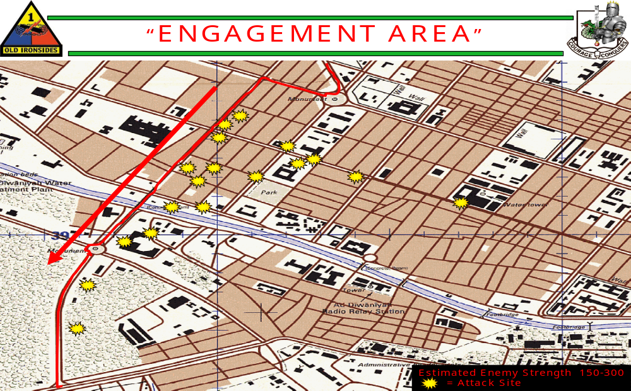

The convoy finally pushed its way forward, and we began to move over the southern bridge, around a traffic circle (MA 91653891) and finally out of the city. As soon as we made the right turn onto the highway heading west, I noticed that there were no other HETs behind mine. I made a guidons call for all Aggressor elements to gain situational awareness and determine the locations of all platoons. Aggressor Blue 3 (SSG Americana Mulitauopele) told me that part of the convoy had taken a wrong turn at the traffic circle and was moving away from the main body. Aggressor Blue 1(1LT Joe Rhyne) realized he had to gain the attention of the HET driver. Since his tank was without communication, he risked his own welfare and crawled from his tank’s turret onto the back of the HET to bang on the window of the cab. Once he had gained the driver’s attention, he directed him to turn around and head back to the traffic circle. Simultaneously, the HET carrying Aggressor White 2 had become disabled just south of the engagement area and was being abandoned by the HET crew. Aggressor White 2 (SSG Kevin Morton), refusing to allow his tank to fall into enemy hands, ordered his gunner into the driver’s compartment, and together, they broke the tank free of the HET tie-down chains, drove the tank off of the HET, and fell back into the convoy. Now, as the HETs began to move south towards the HET consolidation point a traffic jam formed at the traffic circle as the drivers became confused as to which street to take. Still under persistent small arms fire, the HET convoy came to a standstill until the traffic jam could be sorted out. Realizing our dangerous situation and not waiting for orders from higher, I ordered my driver to break the tie-down chains on our HET and get us back into the fight. I contacted my company and stated that I needed the first three tanks that could provide me with full tank crews. Aggressor Red 4(SSG Antonio Costa) immediately volunteered his platoon, Aggressor Red 2(SSG Ronny Coleman) and Aggressor Red 3(SSG Jeff Yager), and this became the counter-attack force to rescue the stranded HETs.
Once I had control of the Aggressor Red platoon, we returned to the traffic circle to find it at a standstill. Vehicles were bumper to bumper, all looking for guidance from anyone who could direct them out of this engagement area. I maneuvered my tank over the curbs and around the HETs to get to the bridge on the northern side of the circle. Aggressor Red 4 and Aggressor Red 2 went through the center of the traffic circle to reach the bridge. It was here that Red 2’s tank found soft ground and immediately became trapped. Not wanting to leave him alone, I ordered Aggressor Red 3 to remain with Red 2 and provide local security while they assessed the situation and attempted to do self-recovery.
I was now forced with the option of defending in place or continuing the counter-attack with only a tank section. With little time for consideration, I pushed my tank forward over the bridge and back into the initial engagement area. As soon as we crested the bridge, I identified the disabled HET. It was swarming with enemy dismounts, seemingly surprised and confused that two tanks were returning back into their engagement area. We immediately began to receive heavy small arms fire again as the enemy tried to reposition to more concealed positions. After confirming that all personnel to our direct front were enemy, we engaged with coax and .50 caliber machine gun fire. The number of enemy was astounding, estimated at well over one hundred, and their volume of fire was increasing as we moved forward. Once my tank had cleared the bridge, the enemy began to displace down the main street to the east, using the buildings and alleyways as cover. An RPG was fired from a near alley that grazed of the front slope of my tank. I identified the enemy sighting in another RPG and immediately opened fire with my AK-47. It was only after eliminating this threat that I realized the enemy were three boys, maybe ten or twelve years old, probably acting on orders from their fathers.
Our two tanks continued to maneuver to the intersection at MA 91993955, the same intersection where the convoy took the brunt of the initial ambush. My tank turned right heading east, and Red 4 took up a position behind me facing north. My tank instantly identified several attackers with AK-47s still on rooftops and hiding in alleys to my direct front. I could see a large number of insurgents focused around the building about 400 meters down on the northern side of the street, but we had to focus on the threats in our immediate vicinity. SGT Ellertson engaged the attackers on the street, and I focused my .50 cal onto the rooftops, both killing numerous enemies. Fortunately for my tank, the enemy was not able to coordinate their attacks and concentrate their fires towards us. Aggressor Red 4 was busy clearing all enemy from the north, protecting my tank from attackers on the flank that I could not identify.
Focusing now on the building 400 meters away buzzing with activity, I saw two bright flashes of light and watched as two RPG’s flew high over our tank and impacted about 100 meters to our rear. SGT Ellertson identified the firer’s location and instantly placed a 120mm MPAT round into the building, eliminating that RPG threat. Another volley of RPG’s was fired towards our location, impacting low and left of my tank. After some creative loading by SGT Ellertson, he placed another 120mm MPAT round into the RPG team. At this point, any remaining attackers fled the immediate vicinity down the alleys and side streets. Fearing a possible flanking maneuver by the enemy, I ordered Red 4 back to the traffic circle to provide local security for the HET drivers while they continued to work their way out of the traffic jam and while Aggressor Red 2 tank continued self-recovery. Joining the fight were Aggressor White 3, Aggressor White 2, and Battlecat White 1, providing additional local security against the small arms fire coming from rooftops and from the roads leading off of the traffic circle.
I pulled back from the main streets, took up a position near the disabled HET at MA 91803919, and requested guidance through Crusader Blue 4 as to the disposition of the HET and Warrior 5’s intent. While awaiting the order to either recover the HET or destroy it, an RPG slammed into the driver’s side door of the HET, and it burst into flames. This seemed to be a rallying cry as the streets were now swarming with enemy dismounts armed with small arms. My tank continued to engage them with our crew-served weapons as the insurgents attempted to maneuver against us using the alleys and parked
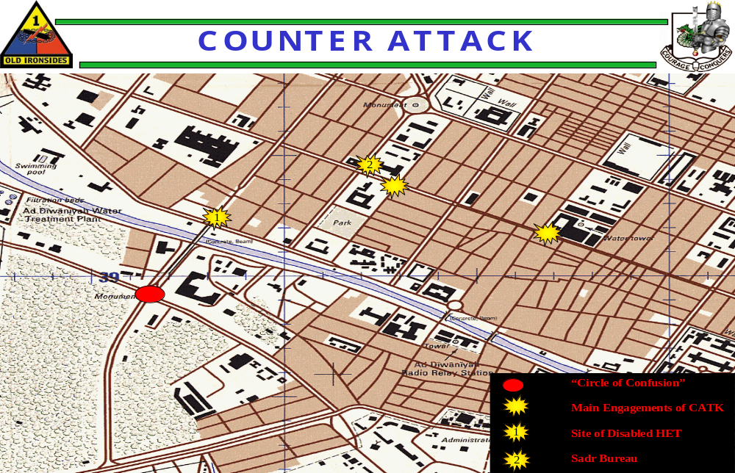
vehicles. They did not seem to have much organization, as their attacks were very disordered and chaotic. This made it easier for my crew to identify each threat and eliminate it accordingly. I continued to monitor both the battalion and company nets to determine the disposition of our convoy.

As darkness fell, about three hours after the initial ambush, my tank had secured the bridge leading out of the city. This allowed the HETs to finally work their way to the HET consolidation point and out of harms way. Now the primary concern was local security for Aggressor Red 2 while he worked to free his tank from the restricted terrain. I noticed a second bridge to the east, about 400 meters away, and, still concerned about a flanking maneuver, ordered Aggressor Red 3 and Aggressor Red 4 to secure that bridge. After determining that self-recovery would not work, Aggressor White 3 was sent back to the HET consolidation point to retrieve the M88 recovery vehicle.
At this point, Battlecat White 1 and a second Battlecat tank assumed the security mission for Aggressor Red 2. On Aggressor White 3’s return, Battlecat White 1 pushed north towards the bridge and provided rear security for my tank. I was still engaged with a number of enemy dismounts and with cars that would try to attempt drive-by shootings. Since these engagements were no more than 500 meters from our position, we were able to destroy these threats immediately.
For a few minutes the city went quiet, providing us with the hope that this engagement would soon be coming to an end. However, two RPG’s were launched from behind some buildings to the northeast in an attempt to use them as indirect fire, but they were very inaccurate and impacted harmlessly away from our vehicles. These RPG’s did start a new wave of small arms fire, as enemy dismounts tried to engage from across the bridge. Aided by the cover of night, these attackers could not accurately identify our locations and were very imprecise and wild, providing us with their locations. With our thermal night vision, our tanks were able to place overwhelming and accurate firepower to neutralize these threats.
Finally I received the call from Aggressor Red 2 that his tank was now operational and we were ready to move to the HET consolidation point. I ordered Aggressor Red 2, Aggressor Red 3, Aggressor White 2 and Aggressor White 3 to escort the M88 recovery vehicle back to the consolidation point while my tank and Aggressor Red 4 provided cover. Once they were moving, Aggressor Red 4 and my tank began our move to the consolidation point. As we made our way around the traffic circle, my driver crossed the road to provide rear security for Aggressor Red 4 and in doing so we became stuck in soft ground. I immediately notified Aggressor Red 4 to hold his position while I appraised my situation. After determining my need for the M88, it returned for a second recovery mission. Red 3 returned with White2 and White3 to aid in local security. Within 5 minutes, the M88 had successfully pulled my tank out and we all returned to the consolidation point, arriving at approximately 2230.
It was at the consolidation point that I found out we had suffered a total of 3 KIA and that they had already been medically evacuated to a Spanish Camp a few miles away. The entire convoy then took complete accountability of all personnel and equipment and prepared for the final 130 kilometer road march to Camp Duke. All tanks with enough fuel were left off of the HET’s and provided security for the convoy as we made our way to An Najaf. Upon arrival, elements from each company met the convoy and directed their vehicles into the FOB. I immediately found my commander, CPT Maynulet, and debriefed him as the rest of the company refueled and prepared for follow on missions.

The company hasty defense, the counter-attack back into Ad Diwaniyah and the recovery of the down tanks lasted well over four hours. We were in constant contact for the duration of those four hours. The main lessons learned from this incident are as follows:

a. Combat operations occurring in a MOUT environment without the mutual support of dismounted infantry must be conducted in the posture of open hatch. There are varying opinions to this, mainly based on the friendly objective: terrain-based or enemy based. I would argue in an enemy based situation that open hatch provides a 360 degree view of the engagement area and that is critical when trying to identify enemy positions that are located at the flanks or rear, especially when you are fighting with limited assets. Enemy contact was made from both at street level and from rooftops, so by fighting open hatch you do present a target of shoulders and up, but this risk is mitigated by the ability to now use our small arms fire (M4 carbine, M9 pistol, Loader’s M240) and destroy enemy at a close range on our flanks. These combatants demonstrated accurate fire and the ability to engage them with all weapons systems is crucial. In addition, being open hatch allows the tank commander and loader to positively identify enemy combatants more precisely and with greater speed than being inside the turret
b. The enemy did not understand the capabilities of our thermal and night vision devices. Once sunset had occurred, a large number of enemy attempted to walk freely out in the streets to reposition on my tank or to retrieve the dead and their equipment. With our thermal sights, we were able to quickly and easily identify combatant from non-combatant and engage. This was a decided factor in the last two hours of the counter-attack.
c. The 120MM main gun of the M1A1 tank was the main weapon system responsible for breaking the enemy’s will to fight. Once we had neutralized the RPG teams with MPAT rounds, demonstrating our willingness to use all available combat firepower, the remaining combatants fled to the alleys and side streets, quickly destroying any arrogance on their part and any attempt at organization.
d. A centralized command and a separate command and control net are crucial to success on the battlefield. In our situation, we had elements from eight separate companies and they were all operating on different frequencies, some even in plain text or on CB radios. When contact was made, there was no unity of command and elements began to defend themselves according to their individual leaders’ guidance. Warrior 5 was on his CB or plain text radio talking to the HET’s and Apache White, I was operating off of FM 102, Battlecat on FM 202, Crusader on FM 302 and Headhunter on either FM 650 or 651 (all nets have been changed for Operational Security). To facilitate the transfer of information, there needs to be one commander and one command net to which leaders from all companies monitor. Once established, net discipline must be enforced to keep this command net clear and for companies to then operate on internal nets.
e. All routes and graphics must be disseminated down to the lowest level so that when an incident like this occurs, all drivers and vehicle commanders are capable of fighting their way out without having to stop and ask for guidance from higher. This would have eliminated a great deal of confusion and possibly allowed the HET’s to clear the city in a much more timely manner, without getting lost and without stopping for an extended time in the engagement area. The HET drivers were provided with a hasty concept sketch of the route from Al Kut to An Najaf, not a detailed military map.
f. The size of this convoy was an absolute hindrance on this entire operation. What was originally meant to be a two-chalk convoy somewhere in the execution became one mass convoy, in excess of over 60 vehicles and spreading a distance of eight kilometers. More emphasis should have been placed on keeping a distinction between the two chalks and their separation. Command and control of such a large convoy was essentially nullified by the sheer magnitude of vehicles involved once the merger had taken place and eventually resulted in the confusion that took place once contact with the enemy had been made.
g. Once contact with the enemy had been established, there was absolutely no attempt made to re-route the convoy or seek an additional bypass. I can only presume that in an attempt to regain what little control of the convoy there was at that time, guidance was instead given for each element of the convoy to merely follow the vehicle to his direct front which in turn led everyone through the main engagement area. Utilizing some basic map reading skills and having some overall situational awareness, the conclusion that there were alternative routes to getting around and out of Ad Diwaniyah could have easily been made. It appears that the decision to continue with the route that was most expeditious placed every soldier in that convoy in harm’s way instead of choosing a safer and more secure route for those vehicles not already decisively engaged with the enemy.

This four-hour fight also saw very heroic fighting from elements of Battlecat, Crusader, HeadHunter and Apache White as well as members from the three transportation companies. Although I do not know the names of all that fought this battle in Ad Diwaniyah, it was a tremendous group effort and we came together remarkably well, considering there were so many elements that had never worked together prior to this occasion. I applaud all of those men who so courageously put themselves in harm’s way to defend the lives of their fellow soldiers and the efforts made to preserve the lives of 1LT Henderson, SGT Hartman and PFC Henson. I’ve heard from various reports that the enemy reports casualties well into the triple digits and I can certainly testify to that count. The soldiers on 17 April placed overwhelming firepower on the enemy from Ad Diwaniyah and I would guess that if given the opportunity to drive back into that city, those insurgents would think twice before attempting such an attack again on US Forces.
“A day after this fight, I received an email from CPT Thomas Moore, of the 1175th Transportation, who was the convoy commander. He wrote: "were it not for the courage and actions under fire of the 2ACR and 2-37 soldiers that day, he is certain all of his men would have been killed." He asked me if he
and his soldiers engaged in that fight with us could wear the 1AD combat patch. I told him I'd be honored.” (MG Dempsey, 2004)

JAMES C. CREMIN
Captain, Armor

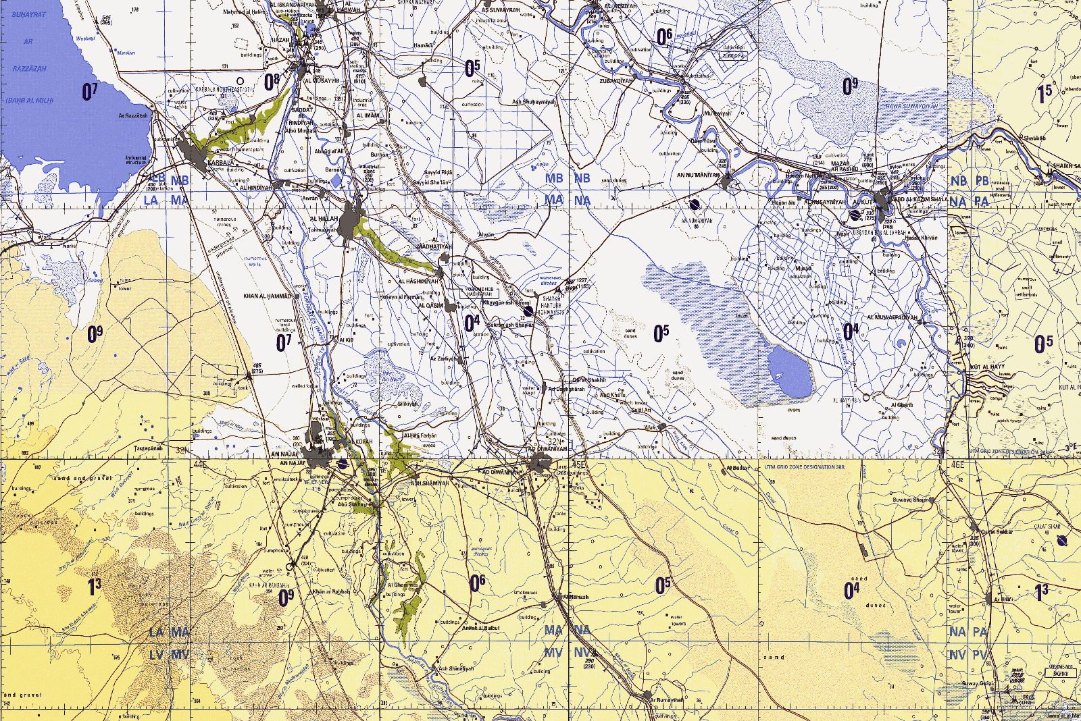
Route from Al-Kut to An-Najaf
AD DIWANIYAH
AL KUT
AN NAJAF
95KM
175KM

